The Liver Group Charity
Chairman’s Statement
2019-2020

I write this statement in lockdown. The COVID-19 crisis has affected all walks of life and all institutions, and the Charity is not immune. The Trustees are therefore taking all necessary and available steps to mitigate the risks, but these are constantly moving and changing so this is no easy task. Some factors, such as grant policies are outside our direct control, though we can seek to influence them; others, such as health and safety of the Charity’s staff we can, and are, taking all necessary measures. The key areas which affect the Charity directly are the continuance of laboratory and clinical work, and fundraising. Both have obviously suffered and been severely curtailed.
Aside from the pandemic though, this has been in many ways a banner year for the Charity, with the completion of a complete working prototype of the bio-artificial liver – now named Hepatican. Professor Selden and her colleagues must be commended for the achievement of this significant milestone.
Like all charities, we rely on the hard work and dedication of our staff and volunteers. I would therefore like to pay tribute to the tireless work of Elise Forster-Brown and Alfie Watt, our University of Bath placement students, in their roles as charity administrative assistants. I would also like to thank Elizaveta Zotova for agreeing to take on this role part time as of 2020.
Finally, we have had some changes on the Board of Trustees. We are delighted to be joined by Mary Collier, whose legal expertise and experience will serve the Charity well. Sadly, we also say goodbye to Sarah Bates, who has served as a Trustee for 17 years. We shall miss her insights and experience deeply and wish her well for the future.

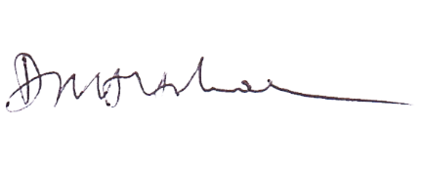
Dr. David Holbrook
Chairman

